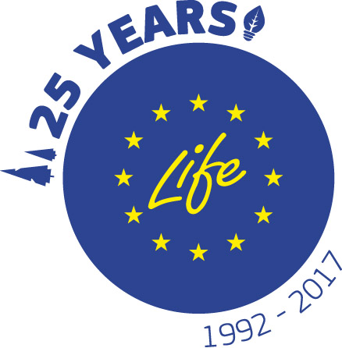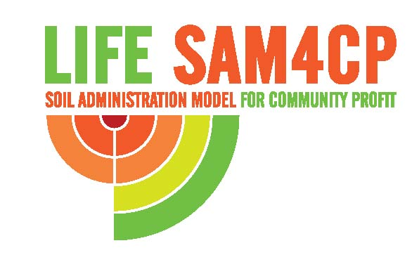

International Conference European project LIFE SAM4CP

“Soil Administration models for community profit”

Soil, ecosystem services, green and blue infrastructures, resilience and planning

16th November 2017
Torino, Sede della Città Metropolitana di Torino
Sala riunioni 15° piano – c.so Inghilterra 7

REGISTRATION FORM

Please confirm the participation before 13th November 2017 to:
sam4cp@cittametropolitana.torino.it

Name/Surname______________________________________________________________________

Institution ___________________________________________________________________________

Adress ____________________________________________________________________________

City ________________________Code__________________________Nation____________________

E-mail _____________________________________________________________________________

For more information please contact Simonetta Alberico Tel. +39 011 8616223, e-mail: sam4cp@cittametropolitana.torino.it

